Shabbos Stories For
Sukkos – simchas torah 5785
Volume 16, Issue 4 15-23 Tishrei 5785/October 17-25, 2024
Printed L’illuy nishmas Nechama bas R’ Noach, a”h
For a free subscription, please forward your request to keren18@juno.com
Past emails can be found on the website – ShabbosStories.com

Lulava
By Rabbi Paysach Krohn



During the Yom Kippur War in 1973, when the Israelis were caught by surprise and attacked by Arabs on all fronts. One of the critical points of battle was near the Suez Canal. For days after Yom Kippur and throughout Sukkos, Rabbi Shammai Parnes and his assistants traveled throughout the Sinai desert, where they cautiously and caringly gathered the bodies of those who had fallen in battle.
Throughout Sukkos, Rabbi Shammai traveled in his jeep, taking with him his Siddur, Tehillim, tallis, and lulav and esrog. In every army camp where he stopped, soldiers approached him, asking for permission to use his lulav and esrog. Infantrymen who were irreligious would pick up his siddur and say, “Rabbi Shammai, let us pray from your siddur or say Shema.”
He would help as many as he could, and at times he was detained from his work for more than an hour. Much to his regret, though, he eventually had to say to the young men, “I cannot stay any longer. I have been summoned elsewhere.” On Hoshana Rabbah, Rabbi Shammai and his assistants were near the Suez. As he drove towards a new army base in the wide-open desert, the thought occurred to him that because he had already used his lulav and esrog for the last time this Yom Tov, he could leave them in the army base.

A Long Line of Soldiers Began to Form
Shortly after Rabbi Shammai’s arrival at the base, a long line of soldiers began to form, waiting to use his lulav and esrog. As a crowd began to assemble, a young non-religious soldier, Arik Shuali, driving an ammunition truck, was making his way southward. Looking through his powerful binoculars he noticed a large crowd of fellow servicemen gathered in one area. Curious, he got out of his truck and made his way on foot to where the soldiers had assembled.
As he came closer, he asked someone, “What is all the commotion about?” They explained to him that Rabbi Shammai had come, and people were waiting for an opportunity to use his lulav and esrog. Arik was not interested in waiting around, but when one of his friends mentioned that it was the last day to do this mitzvah, he agreed to wait.

A Bomb Hit His Truck Just as He Took the Lulav and Esrog
Eventually, Arik’s turn arrived. Just as he received the lulav and esrog, a bomb hit his truck. The vehicle exploded and set off multiple explosions of the ammunition on board. The blasts were so intense that a crater was formed in the ground where the truck had been parked. When they later examined the spot where the truck had been, the soldiers could not find even a shard of metal remaining from the shattered vehicle.
Three months later, Rabbi Shammai read a short notice in the Israeli army newspaper. It was an announcement stating that the wife of serviceman Arik Shuali had given birth to a little girl. The announcement included a statement by the new father: “I believe with every fiber of my being, that I am alive today and that I merited to see my new daughter only because of the Mitzvah that I was doing at the time my truck was bombed.”

Reprinted from the September 20, 2018 website of Torah.Org. The article originally appeared in Inner Net Magazine.

Blast from the Recent Past --Succos 5778 (2017)
Preparations in Crown Heights, Brooklyn

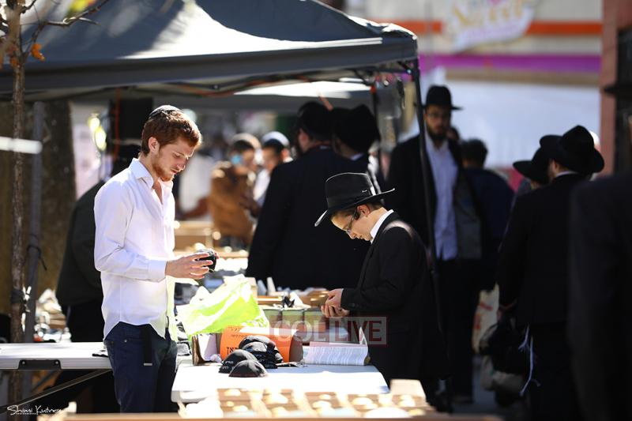
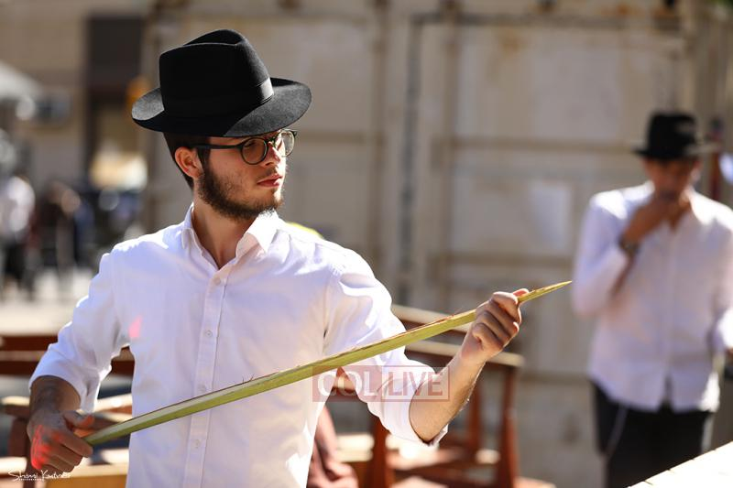
Reprinted from the 5778 Sukkot website of collive.com
The Floating Sukkah
From the Desk of Yerachmiel Tilles

In the year 1915, the governor of the Kiev district in Ukraine was General Dernatalin, a nasty anti-Semite of German origin.
As the festival of Sukkot was nearing the general sought ways to interfere with the preparation for the festival by the Jews living in his district.
He was familiar with the Jewish tradition of eating and spending time [1] in the sukkah that they built in their gardens.

The Governor’s Wicked Plot Against the Jews
After deliberating and consultation with the circle of his acquaintances of like mind, he decided on a malevolent course of action.
Approximately a week before the start of the festival, he publicized a proclamation that it was forbidden to build sukkot in the district of Kiev. The sukkot constituted a fire hazard was the official reason provided. Severe punishment was threatened to those who would transgress the decree.
The farmers of the district received separate orders not to bring wood and branches into the city in the near future.
The city of Kiev was in upheaval; whoever heard of such a thing! To prevent the Jewish people from celebrating the festival of Sukkot according to halacha (Jewish law)?!

The Jewish Delegation is Ignored
That same day a delegation was organized, among them one of the richest Jewish citizens, one successful business man and one well known and talented lawyer. They requested an urgent meeting with the governor. But General Dernatalin, realizing why the meeting was being called, refused to meet with them, giving a transparent excuse.
The overwhelming opinion among the greatly indignant Jewish people was not to give in to the decree. But transgressing it was also impossible. One cannot build a sukkah inside or in other ways hide it from notice.
The police increased their surveillance. Anything at all that might be construed as a possible start to building a sukkah was immediately halted by them.
The city's rich and its dignitaries called a meeting to find a solution. Abruptly the owner of the local shipping company spoke up. "Many ships sail on the Dnieper River," he said, "We will build a big sukkah on one of the ships, and the Jewish citizens of the city will be invited to eat their meals there."
After some thought the lawyer remarked that this idea wasn't a transgression of the governor's edict. After all, he forbade to build sukkot on the ground of his district, nothing was said about the water.
It also removed the reason for the decree: the danger of a fire hazard, since that was not a threat on the water as it was on land.

The Participants Made a Decision to Do the Plan in Total Secrecy
The participants of the meeting were delighted with this solution. They made the decision to go forward with the plan in total secrecy, so that not a whisper of it should reach the general. They had no doubt that he would do everything in his power to obstruct them.
Two days before the beginning of the festival a place was prepared on one of the ships, and two huge sukkot were built. One sukkah was built in the First-Class section which was meant for the rich of the town. Another sukkah was built in the Second-Class section for all the other Jewish persons.
The sukkot were built 100% in accordance with the letter of halacha. The staff of the ship made the kitchens kosher. Enormous amounts of food were prepared for the expected crowds of people. The owner made it known that the meals were free of charge for anyone who wanted to observe the mitzvah of "leishev besukkah” (“dwelling in the sukkah.”)

The Rumor Makes the Rounds to the Jewish People of Kiev
The subterfuge was kept a secret till the day before the beginning of the festival. Only then did a rumor start making the rounds about sukkot that had been built on a ship, that the Jewish people of Kiev were invited to observe the mitzvah of sitting in the sukkah.
Several hours before the beginning of the festival the police discovered the sukkot on the ship. The stared in astonishment at the sukkot, at a loss what to do. The orders they were given had no instructions about what happened on the Dnieper. Neither did they have a justification to order the dismantling of the sukkot on grounds of being a fire hazard.
The Chief of police ran to the governor to inform him of the unexpected turn of events. General Dernatalin, stunned, couldn't believe his ears. He demanded to go see for himself the sukkot built on the river.
The evening had begun and crowds of Jewish people were making their way to the river in order to observe the mitzvah of Sukkot according to the letter of the halacha.
The festive meal began with much joy till the whispers started "Dernatalin is here!"
The latter was beside himself with fury. He threatened to send everyone there to Siberia.
At that point, the Rabbi of Kiev stood up to speak. "Sir, honorable Governor," he said, "you should be aware that there is nothing that can cause a Jew to betray his religion. There is no power in the world that is capable of uprooting from our hearts the mitzvot of the Torah which we received from the Creator more than three thousand years ago. Our holy Torah instructed us to sit in the sukkah, and even though we have been in exile close to two thousand years, we will not desert its commands."
The Governor Silently Departed the Ship
The general listened attentively to the words of the Rabbi. When the Rabbi finished his emotional address, the general went over to him and, much to the surprise of everyone present, shook his hand. Immediately after he silently departed, together with the police officers.
That Sukkot was celebrated by the Jewish people of Kiev with special joy. They celebrated the festival itself as well as the victory over the people who wanted to prevent them observing the mitzvot and instead were overcome.
From that day on a change was noticeable in the governor. He stopped trying the cause trouble for the Jewish people. He even annulled previous decrees he had passed against them.

Reprinted from the Sukkos 5784 email of KabbalaOnline.org, a project of Ascent of Safed in Israel.
The Powerful
Simcha of Sukkot

Rabbi Elimelech Biderman quotes the Chatam Sofer in his Sukkot booklet of Torah Wellsprings. “Sukkot and Shemini Atzeret are even greater than Yom Kippur,” he teaches, “because during Yom Kippur we love Hashem through affliction, and on Simchat Torah, we love Hashem through joy. The mitzvah and the holiness of the holiday come from the Jewish people’s happiness.
On September 1st, 1939, in the middle of the month of Elul, Germany attacked Poland. The bombardment continued for three weeks and didn't stop until September 27th, Erev Sukkot, when the Polish commander surrendered. As soon as the ceasefire went into effect, an amazing phenomenon happened. Despite their bombed homes and the devastation everywhere, the people began to climb out of their shelters.

Hundreds of Warsaw’s Jewish survivors leaped from the cellars and rubble, grabbed broken doors and window frames, and pulled them together to construct Sukkot. By the arrival of sunset – 5:40 pm that day – numerous makeshift Sukkot greeted the holiday, and a few hours later was the first night under German occupation. Gratitude to Hashem is not conditional. Just as He was and is there for us, our appreciation of Hashem will always prevail.
May we all truly appreciate all the good that Hashem has bestowed upon us, our families, and our community. May we have plenty of simcha on these holidays and let it flavor all our days in the future! Tizku leshanim rabot!

Reprinted from the Hag Sukkot 5784 email of Jack E. Rahmey based on the Torah teachings of Rabbi Amram Sananes.

Celebrating Sukkos in Venice, Italy

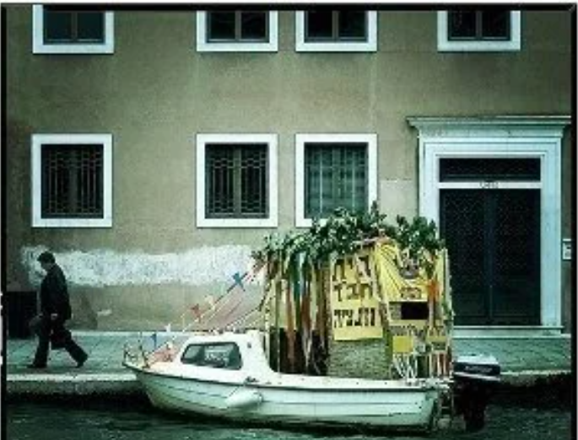

Rav Chaim’s Lulav
By Rabbi Yechiel Spero

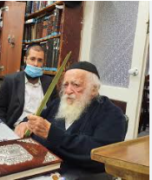

As Rav Yaakov Yisrael Kanievsky, the Steipler Gaon, set out to buy his lulab in Bnei Brak, he was escorted by one of his students, one who had accompanied him for the past few years. This student knew the ins and outs of the business and therefore many dealers had called him to request that the Steipler buy his set of arba minim from them. The young man had chosen one particular dealer, and he and the Rav were on their way to that store.
When the Steipler walked in, all eyes turned to him. Although there were quite a few individuals there when he arrived, he was immediately ushered into a back room so he could examine the lulabim in peace. The nervous dealer had chosen what he thought were the absolute best lulabim in stock and set them out on a table.
The Steipler picked up the first one, examined it, and placed it down on the table where the others were. He then picked up the next one and did the same; each one he selected seemed to have its fault. Finally, he reached the last one on the table, inspected it, and after scrutinizing it closely, put it down. He then went back to the very first lulab he had looked at, one that he had quickly dismissed, and decided to purchase it. The seller, though somewhat perplexed by the Steipler’s behavior, was thrilled to have been able to sell the lulab to the Steipler.
After the Steipler walked out of the shop, his student turned to him and wondered aloud why his Rebbe had settled on that lulab when there were so many other stores and lulabim to choose from. The Steipler was not one to compromise on misvah observance. Why had he settled now?
The answer he gave to his questioning student contained an unforgettable lesson. “It is true. There are many, many shops from which to choose a lulab and etrog. I am certain in fact that I could have bought one that was much nicer than the one I chose. But at what cost? Had I walked out the door without a lulab, then not only would those who were in the outer room have questioned why I left empty-handed, but word would have spread on the street that the Steipler could not find a kosher lulab in this dealer’s shop. This in turn would have caused him to lose many customers. And that is too high a price to pay for a lulab.” (Touched by a Story 3)

Reprinted from the Sukkot 5784 email of Rabbi David Bibi’s Shabbat Shalom from Cyberspace. Excerpted from the ArtScroll book – “Touched by a Story #3” by Rabbi Yechiel Spero.

A Very Special
Simchas Torah Story
By Yitta Halberstam & Judith Levanthal

It was a cold autumn day; the skies covered with the perpetual cloud of ash that hovered daily over Auschwitz. A group of fifty young yeshiva students were herded into the gas chambers, ostensibly for a cold shower. This was well enough into the history of Auschwitz that the cold truth of the cold showers was well known to the young men. They all knew that the nozzles would soon open and bathe them in a cascade of noxious fumes that would choke off their air supply and drain them of life.
The Nazi guards - gleefully awaiting the usual onset of panic, complete with frantic banging on the doors, desperate efforts to reach the sealed windows and futile clawing against bare walls - were surprised by this unique group. Just before the showers released their poison a young man addressed his friends.
"Brothers," he cried, "today is Simchas Torah, when the Jewish world rejoices having concluded their annual reading of the Torah. During our short lives we have tried to uphold the Torah to the best of our ability and now we have one last chance to do so.
“Before we die let us celebrate Simchas Torah one last time. We have nothing; no clothes to cover us or Torah with which to rejoice. But we have G-d who is surely here among us today. So let us dance with G-d Himself before we return our souls to Him."

Upsetting the Nazi Commandant
With this, he placed his hand on his fellow's shoulder and fifty young men broke out in joyous dance, the song of” Purify our hearts to serve you with sincerity" on their lips. The bewildered Nazis stood just beyond the gas chamber and could not understand the meaning of the incongruous celebration. The beastly commandant, who was accustomed to humiliated, broken Jews, could not countenance this spectacle of Jewish pride and flew into a rage.
Bursting into the chamber he grabbed the first boy and demanded to know the reason for the dance. Calmly, the boy replied, "We are celebrating our imminent departure from a world ruled by beasts such as you."
The commandant decided to put an immediate end to the festivities with a cruel announcement. "You think you will escape your tortuous existence in the peaceful gas chamber, but I will grant you a truly painful departure. I will spare you today, but tomorrow I will torture every bone in your bodies; I will slice your flesh till you expire." The commandant ordered the boys released from the gas chambers and housed in a barrack overnight.

Dedicating Their Last Night of Life to G-d and the Torah
Despite their fate, the boys celebrated Simchas Torah all night with joyous song and dance. They sanctified G-d's name by dedicating their last night to expressing gratitude for the privilege of their Jewishness and for the precious gift of the Torah.
Later that night, the boys were miraculously selected for transport to another camp by a high-ranking Nazi official who was not aware of their "crimes." This selection saved their lives and Auschwitz survivors testified that the entire group survived the Holocaust

Reprinted from the Shemini Atzeres-Simchas 5776 Torah Compilation email of Torah Sweet’s Weekly. (Small Miracles of the Holocaust, Halberstam/Leventhal). Comment: On Shemini Atzeres/Simchas Torah it’s just us and Hashem. There is nothing – and no one – who can get in the way of our relationship. That’s how close we can get to our Creator at this time!

